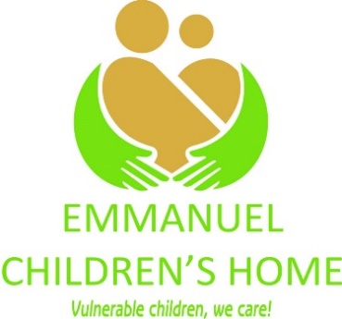
Sikato ARDA Farming Area, Emmanuel Children’s Home. 0772550075/0772944730. alexedmore@yahoo.co.uk or sallychibwana@gmail.com

ORGANIZATION PROFILE
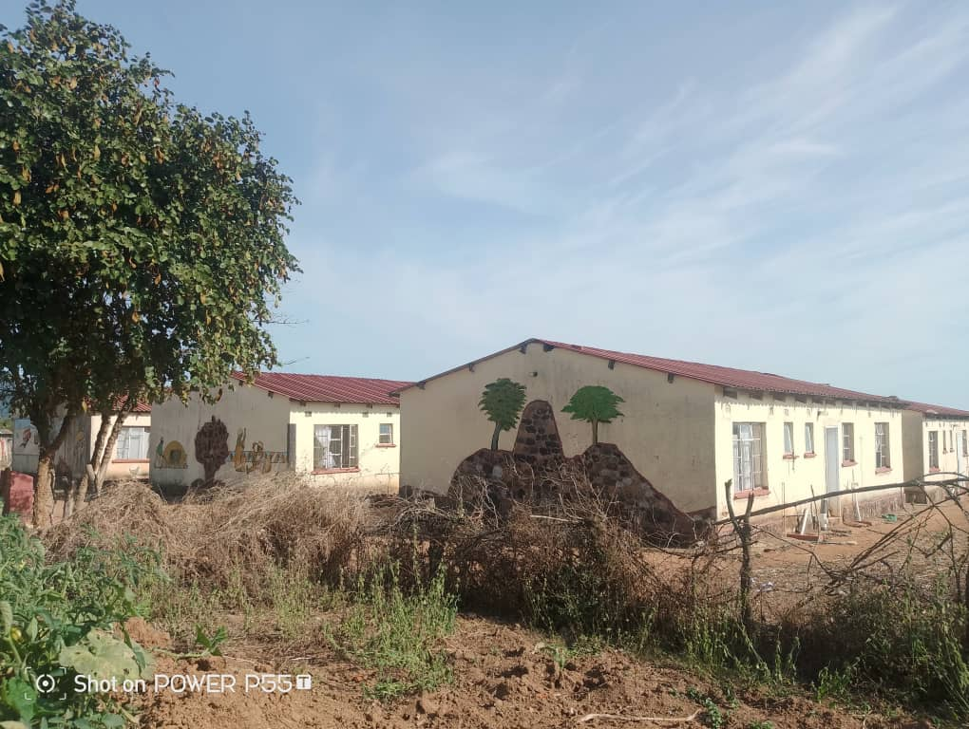
Figure 1 Emmanuel Children's Home
NAME: EMMANUEL CHILDREN’S HOME (ECH)
COUNTRY OF ORIGIN: ZIMBABWE
YEAR OF REGISTRATION: 10 FEBRUARY 2025
REGISTRATION: SW 10/174
PHYSICAL ADDRESS: EMMANUEL HOMESTEAD, Longdale Mushandike Resettlement, SIKATO AREA(FORMERLY ARDA FARM) MASVINGO

Account details:
EMMANUEL CHILDREN’S HOME
BANC ABC
USD Current Account
Masvingo Branch
No. 92118786602000

CONTACT PERSON: chibwana alexander edmore (superintendent)
or matron(saliwe chibwana)
CONTACT DETAILS:
Email: alexedmore@yahoo.co.uk/sallychibwana@gmail.com
Cell: 263 772 550 075/0772944730

VISION: An improved psychosocial wellbeing, accommodating and adding value to the lives of orphans and vulnerable children

MISSION: Capacitating and building resilience of orphans and vulnerable children

AREAS OF OPERATION: Masvingo province.
TARGET GROUPS: Children: orphans; abandoned; neglected; sexually, physically, emotionally and psychologically abused; street children; children with disabilities; children living with HIV and AIDS
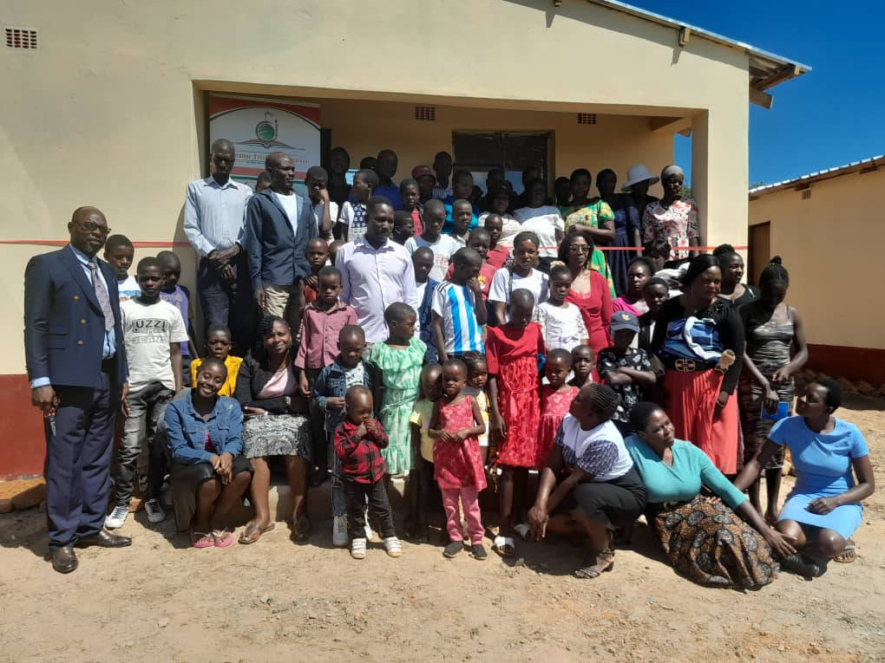
Figure 2 Our children and staff
objectives
1. To improve the psychosocial well being of orphans & vulnerable children
2. To provide safe accommodation to orphans & vulnerable children
3. To train vulnerable children in spiritual matters for ministry
4. To socially & economically empower vulnerable boys and girls
PROGRAMME THEMATIC AREAS:
1) Community Services: Child Protection, Sexual abused and child participation .
2) Alternative Family Care:
● Institutionalization
- Foster Care
- Guardianship
- Facilitation of rehabilitation
3) GIRLS, Youth Empowerment and Male involvement:
- Economic empowerment
- Girls rights awareness
- Familiarization with statutory laws/bills that protects them

4) Early Childhood Care, Education and Youth Development
Interventions
(Achieve universal primary education-Goal 4)
►Direct payment of school fees and purchase of uniforms and stationery
►Provision of pre-school play material
►Support the professional development of teachers through in service training
►Provision of library books
►Support School centred health and feeding programmes

DEVELOPMENTS/ESTABLISHMENT
►2 Ha with perimeter fence
►5 Housing Units with 6 rooms each (30 capacity)
►Church building
►Unfinished admin block
►Incomplete Fowl run
►Pigsty
►Blair toilets

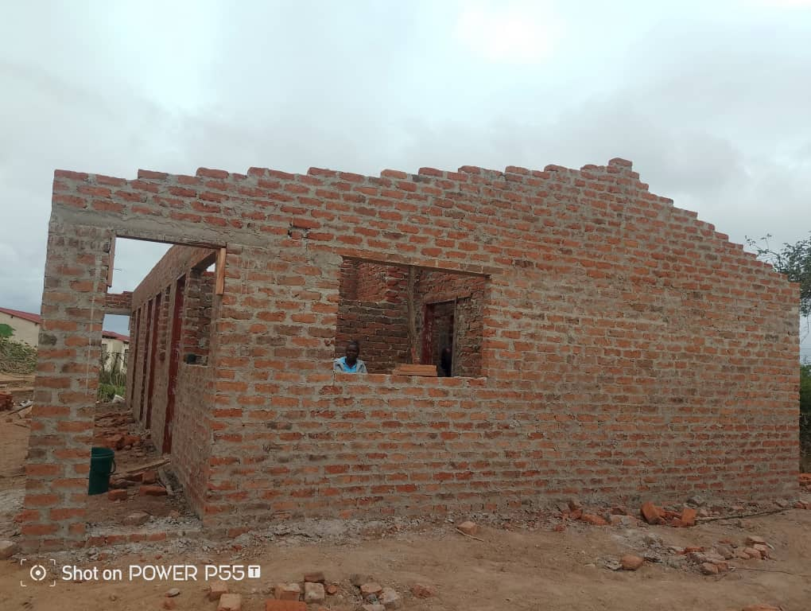
Figure 3: The unfinished Admin Block
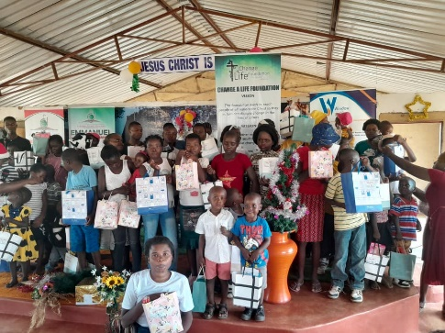
Figure 4: A thank you to our well wishers

CURRENT PROJECTS

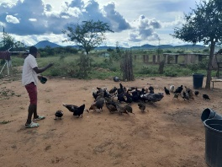
Figure 5: Upskilling our children through the Road Runner Project
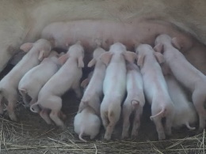
Figure 6: Our piggery project. A source of income and meat for our children
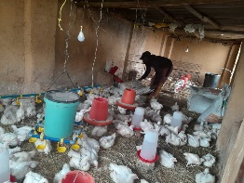
Figure 7: The Broiler Project. A source of meat and income for the home
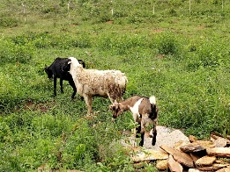
Figure 8: The Goat and Sheep Project in its teething stage

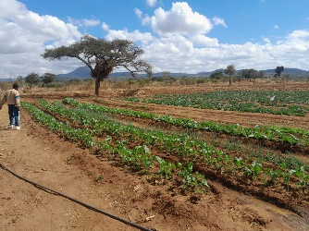
Figure 9: Horticulture Project under drip irrigation

CURRENT NEEDS
● Godly parents beds, blankets & kitchen furnishings
● Admin block completion and furniture
● Drip Irrigation kit
● Broiler project support

Remarks
An orphanage or children’s home was established in 2020 in Masvingo district and registered in 2025by the department of Social Services. The home accommodates 30 children and 10 caregivers or godly parents. The organization is run by an Executive Board (see below). Emmanuel Children’s Home works closely with government line ministries and departments such as Ministry of Health and Child Care, Ministry of Education, Sports and Culture, Local government, department of Social Services and National AIDS Council. The organization also works well with other NGOs and is a member of such umbrella bodies as Zimbabwe AIDS Network (ZAN), National Association for Non Governmental Organizations (NANGO) and Zimbabwe National Council for the Welfare of Children (ZNCWC).
National Board (Chairperson-Mr L.Mudumi(Min of Education), Vice Chairperson-Mrs S. Mapfumo(Business woman), Treasurer-Mr T. Gwaka (Branch Manager Banc ABC), Secretary-Mrs Mazorodze(Businesswoman) and Vice-Mrs Chikaka (Businesswoman.
Committee members: (Mr M. Mubviro and Dr Masinire).
Organogram: Secretariat

